< RATB >

Epidemiological definition
Indicator name | Hospital antibiotic consumption for 1000 hospitalization days
Justification | The quantity of common dispensing units (CDU) dispensed for each presentation of an antibiotic, i.e. the number of tablets, sachets, ampoules, bottles of oral solution, etc., for each pharmaceutical form marketed, is collected from the data supplied by in-house pharmacies (PUI). These quantities are converted into the number of defined daily doses (DDD) for each antibiotic, then automatically related to the activity in order to express the consumption indicator as the number of DDD per 1000 hospital days (HD), in line with national recommendations.  Thus, DDDs must be considered as units of measurement, and do not necessarily reflect prescribed or recommended daily doses (particularly when pharmacokinetic or individual characteristics such as weight, age, renal insufficiency, etc. are taken into account).  Despite the criticisms linked to the absence of a faithful representation of the number of patients or treatments, consumption data presented in number of DDDs can give a general estimate of consumption. This measure makes it possible to track changes over time for a given facility, and more importantly, also enables comparisons between facilities, provided that activity data and any changes in DDDs are taken into account. In the absence of any other simple method that could be used in a number of countries, including for estimating consumption in towns, the use of DDDs was adopted at European level as part of the ESAC [European Surveillance of Antimicrobial Consumption] project. In France, this method of expression is recommended as part of the national plan to preserve the effectiveness of antibiotics.  In healthcare establishments (SPARES national mission: monitoring antibiotic consumption and bacterial resistance in healthcare establishments)  - In 2023, collection of aggregated data following the submission of an Excel file filled in by volunteer establishments (746 healthcare establishments - 38% of hospitalization days at national level in 2023) - consores2 tool under construction.  - DDD/1000HD  National strategy for the prevention of infections and antibiotic resistance (in French) :  https://sante.gouv.fr/IMG/pdf/strategie_nationale_2022-2025_prevention_des_infections_et_de_l_antibioresistance.pdf  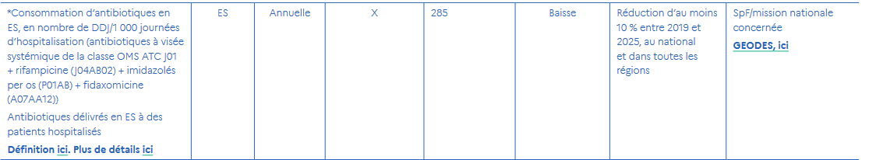  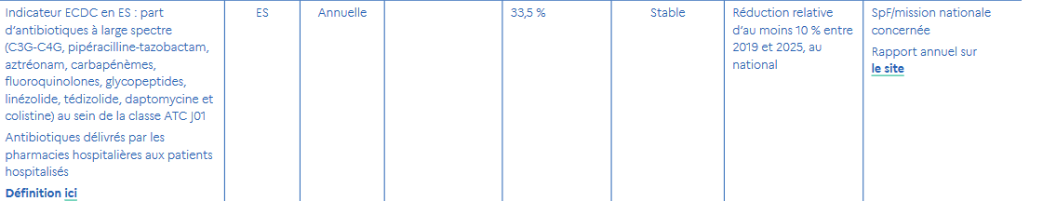
Objective | Surveillance of antibiotic consumption provides monitoring indicators that can be used at local, regional and national level.
Epidemiologic specification | A monitoring indicator must be able to take account of the exposure and the population studied: it therefore comprises a numerator, reflecting the exposure, and a denominator, reflecting the population likely to be exposed.
Numerator / event of interest | There are three types of indicator for monitoring antibiotic use:  - DDD (Defined Daily Dose)  - number of individuals exposed (or newly exposed) per unit of time  - the number of treatments (or new treatments) per unit of time.  DDD :  The DDD is a WHO-defined unit used for comparisons of drug consumption between different populations. It is a reference daily dosage, determined by international experts, which is deemed to represent the usual dosage for an adult weighing 70kg in the main indication of an active ingredient. This is the indicator used by the European Surveillance of Antibiotic Consumption (ESAC) program.  To calculate the number of DDDs (days of treatment at the reference dosage), we need the total quantity in grams of the antibiotic concerned and divide this quantity by the DDD value in grams for the same antibiotic.  Advantages of this indicator :  - easy to implement  - it enables comparison of consumption of a given antibiotic between different geographical areas, since the number of units sold is expressed in a common reference form.  Limitations of this indicator :  - it does not provide information on its own about the number of people exposed during the period. This makes it difficult to interpret the extent of antibiotic exposure outside the context of geographical or temporal comparisons. Nevertheless, this unit performs perfectly well in establishing spatio-temporal comparisons between antibiotic exposure and antibiotic resistance rates.  - it makes it difficult to interpret comparisons when doses or durations actually prescribed vary according to populations.  Examples:  - there are no pediatric DDDs, so comparisons based on population age distributions are impossible; adult DDDs must be used.  - a variation of 1 to 3 g between two geographical areas in the effective dosage for the same indication will lead to the belief that there are 3 times as many people being treated, whereas the number of individuals exposed per unit of time could be identical, and it is the dosage that is 3 times higher. However, the fact remains that, for an equivalent number of individuals, quantitative exposure is 3 times higher.  - in healthcare establishments, boxes delivered by in-house pharmacies are generally considered to have been consumed in clinical departments, which is not necessarily the case (departures, department transfers, changes in treatment, etc.).  It should also be noted that :  - in the case of combined forms of antibiotics, when a combination includes 2 antibiotics, each may have a selection effect on bacteria. In this case, the 2 antibiotics must be dissociated and the 2 respective DDDs taken into account. In the case of sulfonamides in combination, there are two possible scenarios. Either it's a combination with trimethoprim, in which case the WHO has already proposed a DDD, or it's not, in which case it's sufficient to take into account the DDD of the sulfonamide present in the combination. For combinations comprising an antibiotic and an associated inhibitor, if no DDD is proposed by the WHO, only the DDD of the antibiotic will be taken into account.  - it is exceptional for an antibiotic not to have a DDD. However, in the absence of a DDD, it is not possible to take the antibiotic concerned into account.  Number of individuals exposed per unit of time  This would be an ideal indicator, but it is difficult to estimate on the basis of routinely available data, since it requires the availability of daily prescribed doses, actual treatment times, and quantified information on the active ingredient not consumed by the individual for whom the antibiotic was dispensed.  This information is only available through ad hoc surveys, which are virtually incompatible with long-term, geographically widespread monitoring of antibiotic consumption.  Number of treatments  To calculate this indicator, simply count the number of new antibiotic prescriptions per unit of time. This information may be available from certain hospital pharmacies, or by analyzing data from health insurance funds.  Advantages of this indicator :  - it complements the DDJ,  - it provides a good approximation of the number of individuals exposed (or newly exposed) per unit of time.  Limitations of this indicator :  - it does not provide information on the quantities of antibiotics delivered to a population.  - estimating the number of exposed (or newly exposed) individuals using this indicator is more difficult in the case of therapeutic combinations, which is frequently the case in hospital or outpatient settings for certain treatments (e.g. tuberculosis).  ECDC indicator: share of broad-spectrum antibiotics in ATC class J01:  C3-4G, piperacillin-tazobactam combination, aztreonam, carbapenems, fluoroquinolones, glycopeptides, linezolid, tedizolid, daptomycin and colistin.  Proxy definition of preliminary ATB consumption is based on the following ATC dispensing :  - J01  - J04AB02  - P01AB  - A07AA11 and A07AA12  - A02BD08  - J04AM02 and J04AM05  To convert to CDU codes
Denominator | The denominator to be taken into account must be the number of hospitalization days in the year studied.  The result will be expressed in DDD/1000 hospital days, by multiplying the ratio between the number of antibiotic DDD for the year studied/number of hospital days for the year studied by 1000.  Hospitalization days correspond to the number of days billed by the admissions office or equivalent structure, and also take into account day hospitalization and weekday hospitalization.
Adjustment | when necessary, method of adjustment, standardisation, or weighting
Data source | Hospital Health Data Warehouse
Form of result | The unit for monitoring antibiotic use is: the number of DDD per 1000 patients per day, which is estimated by the number of DDD per 1000 hospitalization days.
List of variables necessary for indicators and metrological assessment | - Medical specialty (to define)  - CDU  - Number of CDU  - Month  - Year  Antibiotic consumption data  The quantity of common dispensing units (CDUs) dispensed for each presentation of an antibiotic, i.e. the number of tablets, sachets, ampoules, bottles of oral solution, etc. for each pharmaceutical form marketed, will be collected from the data of in-house pharmacies (PUI).
Output format | graphic representation (e.g. curves, histograms, bar charts) and interpretation rules
Distribution process | frequency of result production, target audience for the results, and access mechanisms (e.g. internet platform), including whether there is open access for the general public
Ethical requirements / recommendation

Technical specifications
technical documentation needed to move from general definition of indicator to calculating it in a reproducible way
Numerator / event of interest | DDD Number
Denominator | Number of hospitalization days (SPARES strict definition or including overnight stays)
Adjustment | DDD Number * 1000 / Number of hospitalization days
Calculation method | CDU enables the determination of the unit dose, route of administration, ATC code and associated DDD  UCD number * unit dose / DDD = DDJ number
Output format | Stratifications:  - by antibiotic class (ATC level 4)  - Medical specialty (to define)  - Criticality (AWARE, SPILF)  - Annual and monthly results  Representations:  - pie chart: distribution of consumption by antibiotic class  - bar chart: evolution by year and by month
Data Management | Data Format/ Data collection tools, Unique identifier, etc.
Indicator calculation version | date and version

Metrological properties
Development phase
Definition | approval process for the general definition of the indicator: sources of information used (e.g. bibliography, expert opinions, working group, etc.) and validation method (e.g. meeting, consensus, etc.)
Algorithm | approval of the lists of variables (or calculation algorithm) by experts according to the general definition
Empirical measurement | description of the method (e.g. data period, etc.)  main results (e.g. number of calculable events depending on data source, number of missing data depending on data source, production time depending on data source, etc.)
Validation phase
Comparison with a gold standard | carried out or not / if carried out: description of method (e.g. number of health records analysed, study period, records selection method, evaluation method, etc.)  main results (e.g. estimated positive predictive value, analysis of false positives),
Comparison with other indicators | carried out or not / if carried out: choice of indicators, description of sources  main results (e.g. correlation analysis)
Adjustment | carried out or not / if carried out: choice of adjustment variables (method used), choice of adjustment method, description of statistical analysis method  main results (e.g. comparison of observed and adjusted results, performance of statistical models)
Comparison over time | carried out or not / if carried out: description of method used (e.g. predictive model using time series)  main results (e.g. estimated accuracy of indicator measurement, identification of alert threshold)
Use phase
Comparison between hospitals | carried out or not / if carried out: choice of comparison method, description of comparison method, definition of comparator  main results (e.g. dispersion relative to comparator, identification of atypical entities)
Data visualization | evaluated or not / if evaluated: description of evaluation method  main results (e.g. users' opinions on how the results are reported and interpreted)
Date | date / study period metrological quality results

